Name: Sumama Rahim
Reg# F24BSCS039
Course: Information Security
Instructor: Dr. Zia
Date: 01/09/2026

Lab – Task

Code:

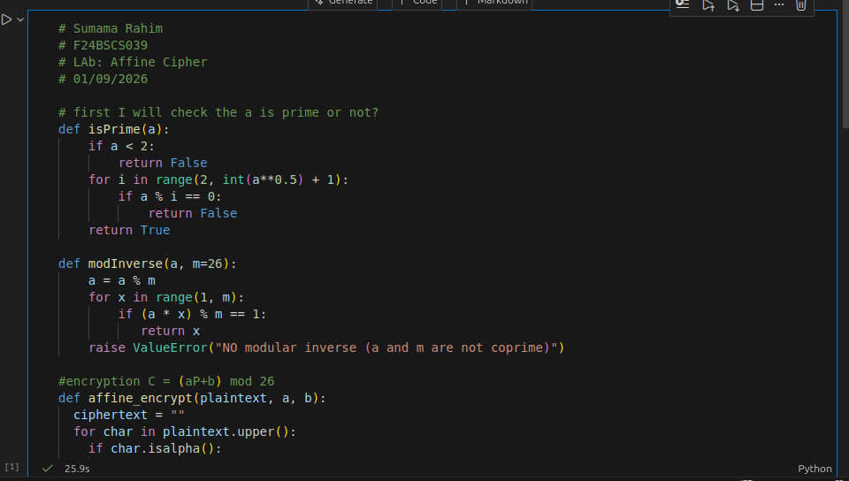
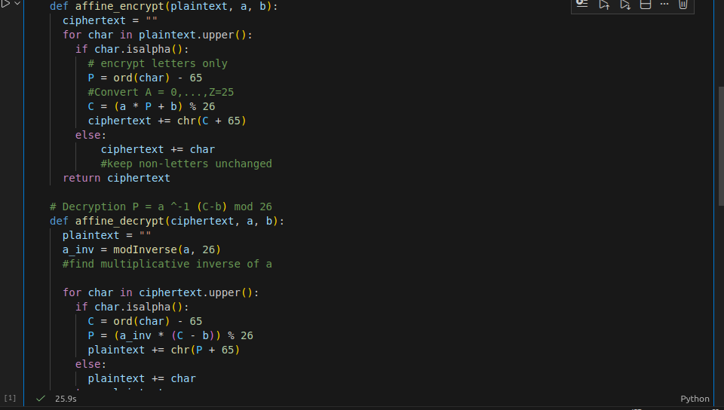

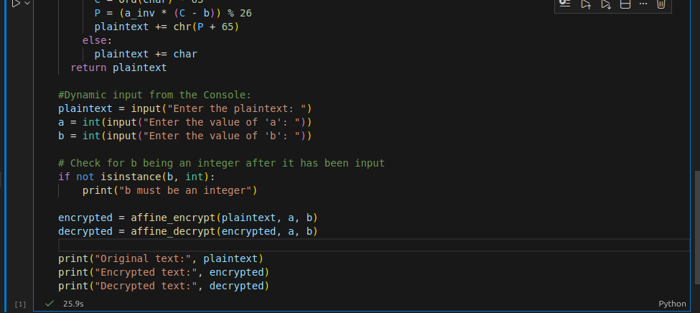

Output

